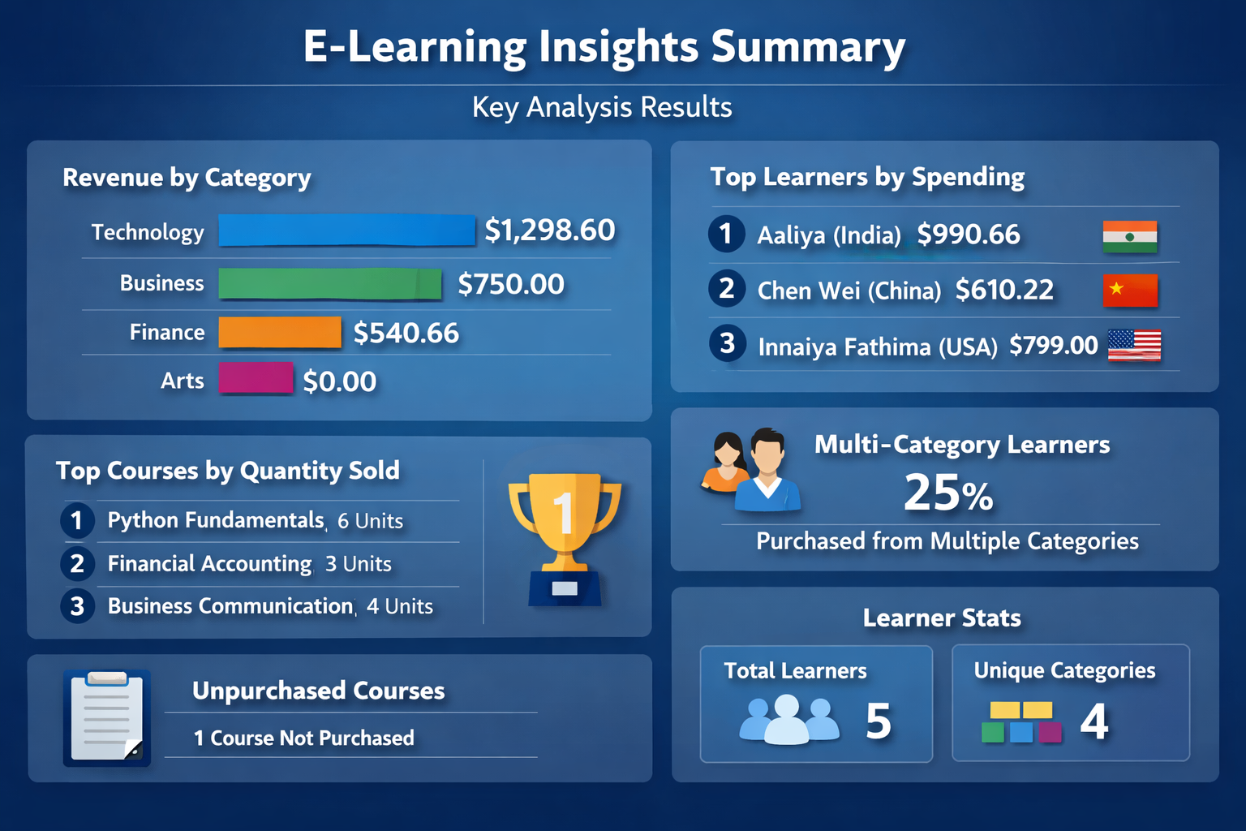

📊 Course Pricing & Categories
- Technology courses (Power BI, Python Fundamentals) are the most expensive, driving higher average and total prices.
- Arts and Finance courses are priced lower, making them more accessible but contributing less to overall revenue.
👩‍🎓 Learner Purchase Behavior
- Every learner has purchased at least one course, but spending varies widely.
- Aaliya (India) and Chen Wei (China) stand out for purchasing multiple courses across categories, showing cross-domain interest.
- Some learners (e.g., Goldina Thomas, Germany) bought only one course, indicating more focused preferences.
💰 Spending Insights
- Top spenders are those who purchased higher-priced technology or finance courses in larger quantities.
- Learners from different countries show diverse spending patterns, with India and China contributing significantly to multi-category purchases.
📈 Course Popularity
- Python Fundamentals and Financial Accounting are among the most purchased courses, reflecting demand for both technical and finance skills.
- Creative Writing has fewer purchases, suggesting lower demand compared to business/technology courses.
🏆 Top 3 Courses by Quantity Sold
- Courses with higher unit prices (like Python Fundamentals) still rank high, showing strong demand despite cost.
- Business and Finance courses also appear in the top 3, highlighting balanced interest across domains.
📂 Category-Level Revenue
- Technology generates the highest revenue, driven by both price and demand.
- Business and Finance categories contribute meaningfully, while Arts lags behind in revenue.
- Unique learner counts show that multiple learners engage with each category, but Technology dominates in both reach and revenue.
🔄 Cross-Category Engagement
- Several learners purchased from more than one category, showing diverse learning interests.
- This indicates potential for bundled offerings (e.g., combining Technology + Business courses).
🚫 Unpurchased Courses
- At least one course (depending on your dataset, e.g., if any course didn’t appear in purchases) remains unpurchased, highlighting areas where marketing or curriculum adjustments may be needed.
✅ Overall Takeaway:
- Technology courses are the revenue leaders.
- A few learners drive cross-category engagement, while others remain focused.
- There’s untapped potential in Arts courses and unpurchased offerings, suggesting opportunities for promotions or curriculum redesign.

